This syllabus courtesy of the

Vernacular Architecture Forum Syllabus Exchange

A collaborative project of the Vernacular Architecture Forum
www.vafweb.org/resources/syllabi.html

instructor: Phil Gruen
course title: Reading the American Landscape
institution: Washington State University
date offered: Spring 2019

posted date: December 2019
stable URL: www.vafweb.org/resources/syllabi/gruen1

This document is provided for non-commercial, informational purposes only

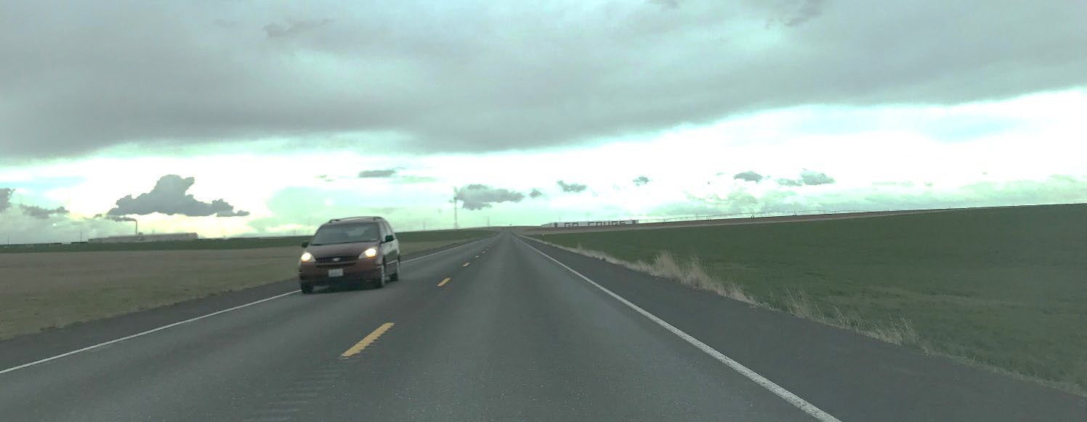
Reading the American Landscape
Honors 280.3 | Contextual Understanding in the Arts and Humanities Tuesdays and Thursdays | 4:15pm-5:30pm | Elmina White Honors Hall 142
Spring 2019 | 3 Credits

Associate Professor: Phil Gruen
Email/Phone: jpgruen@wsu.edu / 509-335-2309
Office Hours: Mondays, 11:00am-2:00pm, Daggy Hall 318

Course Description: Is it possible to read, understand, and appreciate the totality of the American landscape: its farms, grain elevators, indigenous communities, small towns, suburbs, roads, and restaurants as well as its spectacular national parks, glittering skyscrapers, and exquisite residences? This course is intended to deepen our understanding of the American built environment and, by extension, American culture. We will critically investigate everyday or vernacular landscapes built by ordinary people and often shaped by politics, economics, race, and gender; that is, meaningful spaces and places that comprise the vast majority of our physical settings but are typically overlooked in favor of professionally-designed, high-style landscapes. To provide tools for reading the landscape, we will employ disciplinary methods from the visual arts, architecture, history, geography, anthropology, and literature. A segment of the course will feature our regional landscape: the Pacific Northwest, eastern Washington, the Palouse, Pullman, and WSU. For contextual, comparative, and historical purposes, examples may be drawn from across the globe.

Required Course Materials:
Blackboard access (for articles, links, videos): learn.wsu.edu

Learning Outcomes: Students will become familiar with the “landscape” in its myriad manifestations—as nature, and as culture; as urban, and as rural; as “high” as well as “low.” In particular, students will be provided with a theoretical lens upon which to study and appreciate the landscape: one that roots the physical environment within its ethnic, economic, spiritual, philosophical, and historical context; in short, one that roots the environment within a cultural landscape. In this respect, students will learn the importance of understanding the people who built, theorized, or shaped the land.

For example, rather than simply appreciating a work of architecture, a ranch, or a city for its aesthetic beauty, students will learn that a beautiful landscape might exist because it belongs to an elite, wealthy class that has the money or power necessary to maintain it as such. What might often be perceived as an “ugly” landscape (say, a factory), moreover, might represent somebody’s livelihood and, for that person, a type of beauty. Via readings, discussion, presentations, and assignments, students will learn to approach landscapes from a variety of perspectives.

It is hoped, too, that students will become teachers in this class, immersing themselves in an academic research culture through critical analysis of readings, oral presentations, and primary research. Students are encouraged to delve into original documents, including oral histories, to provide insight into topics or landscapes that have not yet been investigated or properly understood. A desired outcome is that students will learn to have confidence in their abilities to conduct original research and will thus contribute in a meaningful way to the academic community—and the public.

Course Activities & Requirements: This course will be a mix of lectures, readings, discussion, movies, videos, field exploration, and student presentations. A student-created internet-related project (the Wikipedia assignment) will constitute the principal written assignment for the semester, and it will provide an opportunity for students to be “published”—or at least to experience how Wikipedia—a widely used source of information, is publishing. To help illuminate our readings and discussions, our location in White Hall may permit short “field trips” around campus and/or Pullman during class time (weather permitting). One trip and reflection through the Center for Civic Engagement (CCE) will be required, as well. In-class student participation (discussion) and presentations, however, will account for the majority of the final grade.

- Lectures: On Tuesdays, the professor will prepare a lecture or presentation that relates to the week’s theme, featuring ideas broadly representative of the week’s readings. The lectures are not intended to be all-encompassing summaries of those themes; rather, they will focus on landscapes or building types that could serve as examples for them, and they may introduce other themes.

- Readings: Posted to Blackboard as PDFs or links at least by Friday at 5pm, and hopefully earlier, prior to the next week’s meetings. The professor may adjust any readings as necessary to cohere with class flow, including the addition of media such as movies or video clips, or the removal of certain readings). For student teams preparing Thursday presentations, readings may be requested from the professor at an earlier date. All students, however, are responsible for reading the assigned material and arriving in class prepared to discuss them.

It is difficult to remember every detail of every reading, and it is not expected that you do so. However, do read intelligently: take notes as you read and attempt to identify the thesis/argument of the readings (if there is one, or if there are many) as well as some of the principal examples the author(s) use to illustrate their point(s). Do you agree or disagree with their contentions, or the approaches they are suggesting? What other examples or methods do you think might have been more appropriate to include? If you have questions while you are reading, write them down and be prepared to raise them during class time—whether or not those questions are elicited by the discussion leaders (teams).

- General Discussion: This course features professor-led lectures/discussions on Tuesdays and student-led lectures/discussions, including presentations, on Thursdays. Each Tuesday, the professor will lecture and/or initiate discussion on the week’s theme, with some reference to the reading (or other assigned media that may be added) for that week. Each Thursday, selected teams (five students) will lead the class, beginning with a presentation (see

“Student Presentations” below) and questions/queries/activities related to the readings and week’s theme.

Regardless of who is leading the class, all students must attempt to participate, ask questions, and offer opinions relevant to the readings or course material—even, or especially, if they are not presenting and/or leading discussion that day. Student discussion accounts for a hefty proportion of the final grade, so all students must come to class prepared, having completed the readings and/or assignment(s) and ready to discuss them. Ideally, the course should be able to run for the full hour-and-fifteen-minutes, even if the professor or team presenters are absent. On the flip side, particularly loquacious students should be sure to permit others to speak; badinage is encouraged, but students must be respectful to one another (and to the professor). There may be times when the format will be altered to accommodate exams, guest lecturers, or other topics or events.

- Teams: On most Thursdays of the semester, beginning in week three, a team will be responsible for researching, finding a video clip (or making one), and presenting an American landscape or landscapes relevant to—but not necessarily included in—the readings and/or lecture for that week, and then leading class discussion the remainder of the period. Each student in the class will participate in two different teams during the semester, and we will try to ensure that the second set of teams is completely different than the first. Teams are encouraged to check with the professor to determine the appropriateness and relevance of their chosen landscape to course material. All students in a team will receive the same grade for its session (including leading the discussion afterwards), no matter the level of participation, involvement, and energy. Teams should arrange to meet outside of class time to prepare for the presentation (including the selection of the video) and discussion lead. Unless there are extenuating circumstances, no switching of teams is permitted. Students are encouraged to work collaboratively as much as possible; the professor is not interested in hearing complaints about other team members not participating or performing the work.

Team Presentations: The presentation should begin the class period, and a related video should be shown. Teams must choose one American landscape by searching online, traveling in the Palouse, walking around campus, or anything the team would like, old or new, local or global—so long the team is able to connect it to course material; that it inspires class discussion; that it includes a video clip related to the topic; and that it is reasonable to discuss in the class period (e.g., a neighborhood farmer’s market is reasonable in terms of scope; something like “the city of Miami” is not).

Teams should limit the initial presentation to twenty-five (25) minutes or less, including the video, and should work to ensure that all students in the team have a chance to speak or participate in some way. Audibility is key; presenting in a lively—even entertaining— fashion is highly encouraged. The following questions should be addressed, either explicitly or implicitly (or at least attempted):
  - What is your landscape/site? When was it built/designed, by whom (if known), and for what function? Where is it?
  - How, and in what ways, does your landscape/site relate to the lecture, readings, and/or media for the week?

  - Have there been changes over time?
  - Was your video selection relevant to the week’s theme, and were you able to analyze it as well—or otherwise inspire the class to discuss it?
  - Why did you choose this landscape/site?
  - What is the significance of your landscape/site? (If this is not immediately obvious, what sorts of clues do you get from the readings or lectures that suggest it might be significant? How would you find this significance?)
  - If you had more time, what else would you like to discover about your landscape/site?

Team Discussion Leads: Following the presentations, teams are further responsible for sitting (or standing) together and leading or inspiring class discussion for the rest of the class period. Teams may choose to lead discussion in the traditional way (just asking questions) but could inspire discussion through other means, such as images, more videos, interactive games, handouts, or other team exercises. Students should feel free to rearrange the room furniture to facilitate interaction if needed. While all students (and the professor) should attempt to participate in the discussion, teams must be prepared to fill gaps or generate more questions/activities if the class discussion is lacking.

Team discussion leaders are also encouraged to try methods of leading the session in ways that are different from those of previous weeks. There may be an occasional week where the professor will ask the team leaders specifically to introduce material in a particular way—or at least to ensure that certain aspects of the reading are discussed.
Even for those weeks, however, team leaders are expected to facilitate the majority of the discussion.

Videos: As with the general manner in which discussion is led, there is flexibility in the type of video that could be shown. It does not have to be “academic,” for example, or professionally made, but it should relate to the class topic. It could be downloaded from YouTube, for example, or made by the team members. Please contact the professor if you are apprehensive about the relevance of your chosen video.

- CCE/Field Exploration: All students will engage in field exploration through a selection of Center for Civic Engagement (CCE)-led activities prior to April 9 (just one is required). Round-trip transportation is provided by the CCE.

The Center for Civic Engagement (CCE) offers WSU students, faculty, campus departments, and community partners opportunities to share knowledge, skills, and resources for the benefit of student learning and the well-being of our communities. The CCE facilitates service learning experiences as part of academic curricula and will be working with this class to provide appropriate community-based and/or civic leadership experiences for students.

You will manage your service learning experience on CougSync. The system tracks your activities and can provide you with a record of involvement to show all of the activities you have participated in at WSU. This will be a great resource when applying for jobs and/or graduate school! You should receive an email inviting you to your course portal on CougSync. Log on to CougSync using your WSU network ID and password to access your

course portal. If you have not yet received this email or have any questions please contact a peer mentor at the CCE (cce@wsu.edu or 509.335.7708), stop by the CCE’s Student Resource Center in the CUB, L 45, or visit cce.wsu.edu.

The options for Honors 280 in spring 2019 will be the White Spring Ranch in Genesee, Idaho (Saturdays, 10am-3pm); the Palouse Conservation District in Pullman (Fridays & Sundays, 12pm-3pm), the Palouse-Clearwater Environmental Institute in Moscow (Wednesdays, 2:30pm-5:30pm), and the Whitman Conservation District in Colfax (Fridays, 1:00-5:30). CCE representative(s) will visit our class both near the beginning and mid- semester to orient students and engage in reflection activities; all students also will be required to turn in a written response to the activity, due before April 9. This assignment will be worth 10% of your overall course grade.

Weather permitting, during class, we may take a short trip from White Hall to consider campus landscapes or those on College Hill or downtown.

- Exams: There will be no formal examinations in this class, but students are required to assemble for the final exam period for discussion and reflection.

- Wikipedia Entry Project: Students will select a landscape (or some aspect of the built environment) and create a thoughtful and sophisticated Wikipedia entry—from scratch—for it. Students are encouraged, though not required, to choose a final project topic that enables visitation and first-hand experience during the semester (as well as orignial photos that can be uploaded onto the page). The topic selection cannot be that for which any discussion team focused upon during a regular Thursday meeting, and cannot already have a Wikipedia entry. Students will work to discover what it takes to create a Wikipedia entry, and what is required to ensure that it is not removed. Students will not, however, be graded on whether the Wikipedia entry remains for a lengthy period (pages can be taken down for any number of reasons), but whether the project follows the assignment parameters, makes an argument that can be supported with evidence (class readings, for example), and includes original research. Students will be asked to turn in at least one draft of this assignment during the semester, where s/he will receive written feedback. For the final version, while a live Wikipedia entry is desirable, screenshots in Wikipedia format will suffice. Students also will be asked to turn in word documents of their page(s) as backup for the draft and the final project, and will be graded on the content therein.

- Wikipedia Entry Presentations: In the final weeks of class, all class members will have eight total minutes to present their Wikipedia entry. This includes questions, set-up, and comments. Students should keep their presentations to no more than five minutes. Similar to the team presentations, audience members should understand why you chose your site and why it is significant.

Grading Breakdown (approximate)
General discussion: 25%
CCE/Field Exploration: 10%
Team presentations and class discussion leads: 20% Wikipedia Entry Draft: 10%

Wikipedia Entry Final Project: 25% Wikipedia Entry Final Presentation: 10%

Note: The final grade will be determined largely as an average of all semester grades. However, more than three unexcused absences and/or violations of class civility may lower the final grade.
Intangible aspects such as extra effort, interest, and enthusiasm may raise the final grade.

Grading Scale: Individual assignments will be calculated on a 100-point scale. For those assignments, any grades that include percentage points of .5 and above will be rounded up to the nearest whole number (e.g. a 92.5 will become a 93; a 79.7 becomes an 80). For final grades, all point totals will be averaged based upon the number of assignments. For final semester grades that average out to split grades (e.g. an 87, or a B+/B), students will be granted the higher grade.

100 = A | 89 = B+ | 79 = C+ | 69 = D+ | 59↓ = F
99 = A | 88 = B+ | 78 = C+ | 68 = D+
98 = A | 87 = B+/B | 77 = C+/C | 67 = D+/D
97 = A | 86 = B | 76 = C | 66 = D
96 = A | 85 = B | 75 = C | 65 = D
95 = A | 84 = B | 74 = C | 64 = D
94 = A | 83 = B/B- | 73 = C/C- | 63 = D/D-
93 = A/A- | 82 = B- | 72 = C- | 62 = D-
92 = A- | 81 = B- | 71 = C- | 61 = D-
91 = A- | 80 = B- | 70 = C- | 60 = D-
90 = A-

Course Policies

- Civility: While a comfortable environment for discussion is highly encouraged, please refrain from talking, private conversations, excessive noise, and so on during class time— unless it is based upon the class discussion or related to the material (and that you are also willing to share it with the class). While debate and disagreement about course material is certainly acceptable, please also exhibit courtesy, or civility, towards your fellow colleagues and the professor. Please avoid the use of your phones, tablets, etc. during class time unless it is an emergency, and please avoid use of the internet unless otherwise instructed or you are willing to share what you find. Otherwise, the professor may choose to share that material for you. Violations of civility may lower your final grade for the semester.

- Attendance & Lateness: More than three unexcused absences may also affect the final grade. While notes from health care professionals are not required, according to WSU Academic Regulations 72 (Office of the Registrar), students who attempt to gain advantage through abuse of this policy (e.g., by providing an instructor with false information) may be referred to university authorities. There will be a sign-up sheet to accompany each class session, so be sure to sign the sheet before leaving class. Please do not ask to sign the sheet retroactively or ask others to sign in for you. If there is an impending conflict with a week for which you have been selected for a team presentation, please consult the professor (and your fellow team members) and we will see what we can do. Finally, while it is

understandable that lateness may happen occasionally for any number of reasons, please do your best to arrive on time, as there may be important announcements made at the beginning of class.

- Mid-semester Grades: The university requires all undergraduate students to receive mid- semester “in progress” grades. I will upload a grade for you by the designated date but please be advised that only a limited number of graded assignments may have been completed at that time. Thus, while your mid-semester grade may be indicative of the average of your overall progress up to that time, it is not necessarily indicative of the grade you will receive for the course. The mid-semester grade is merely advisory and—while it is possible you will end up with the same final grade as your mid-semester grade, the mid- semester grade itself will not show up on your final transcript for this course.

- Academic Integrity: Academic integrity is the cornerstone of higher education. As such, all members of the university community share responsibility for maintaining and promoting the principles of integrity in all activities, including academic integrity and honest scholarship. Academic integrity will be strongly enforced in this course. This includes any forms of cheating, which includes, but is not limited to, plagiarism and unauthorized collaboration as defined in the Standards of Conduct for Students, WAC 504-26-
010(3). Washington State University reserves the right and the power to discipline or to exclude students who engage in academic dishonesty. Violations of academic integrity will be adjudicated according to university policies and procedures. The WSU policy on academic dishonesty is linked through the Conduct Policies as determined by the Office of Student Conduct here: https://conduct.wsu.edu/policies/. The penalty for a violation of academic integrity on any exam or assignment in this course will be a failing grade on that particular exam or assignment. This could result in a failing course grade as well as dismissal from the university.

- Safety: WSU has developed a resource in support of its commitment to the safety of students, faculty, staff and visitors. Students are encouraged to review the Pullman Campus Safety Plan (http://safetyplan.wsu.edu) and the WSU Office of Emergency Management website (http://oem.wsu.edu). Additionally, students should also become familiar with the WSU ALERT site (http://alert.wsu.edu), which provides information about emergencies and other issues affecting WSU. This site also provides information on the communication resources WSU will use to provide warning and notification during emergencies. It should be bookmarked on computers, and it is recommended that all students should go to their “mywsu” portal at http://my.wsu.edu and register their emergency contact information under the “Pullman Emergency Information” if they have not already done so.

•
Students with Disabilities: Reasonable accommodations are available for students with documented disabilities or chronic medical conditions. If you have a disability and need accommodations to fully participate in this class, please visit the Access Center website to follow published procedures to request accommodations: http://www.accesscenter.wsu.edu. Students may also either call 509.335.3417 or visit the Access Center in person to schedule an appointment with an Access Advisor. All disability related accommodations MUST be approved through the Access Center. Students with approved accommodations are strongly

encouraged to visit with instructors early in the semester during office hours to discuss logistics.

- Accommodating Religious Observances in the Administration of Examinations: WSU is committed to providing people of diverse religious backgrounds access to education. Should you require special accommodations for an presentation or exam due to religious observances (e.g. religious holidays), please contact the professor at least fourteen days in advance. For more information, scroll down to WSU Academic Regulation 82 on the following website: https://registrar.wsu.edu/academic-regulations/.

Learning goals rubric:

WSU learning goal | WSU learning outcome(s) | Course-level learning outcome (by the end of  this course, students will be able to …) | Learning activities and assignments | Learning outcome will be assessed by…
Creative and critical thinking | - Defining and solving problems  - Integrating and synthesizing knowledge from multiple sources | - Understand the debates between nature and culture  - Understand the debates between “high” and “low” design  - Recognize how a wide range of disciplines can contribute to our understanding of the landscape | - Lectures  - Readings  - Class presentations | - Feedback and participation in class
Information literacy | - Learn to access information effectively and efficiently from multiple sources  - Learn to assess credibility and applicability of sources | - Understand the difference between scholarly and non- scholarly sources  - Recognize the importance of original research and citations  - Proper and consistent formatting | - Draft of internet- based original research project, where sources and citations are checked | - Reliable sources (e.g. web links are accessible and up- to-date)  - Properly formatted citations (checked and graded)  - Ability to revise and respond to feedback
Depth, breadth, and integration of learning | - Broad study across the arts and humanities  - Recognizing the interdisciplinary nature of the subject | - Recognize that landscape studies emerges only from readings from a wide range of disciplinary backgrounds | - General (class) discussion  - Assignments that require scholarly sources | - Class discussion and assignments that examine whether students are approaching topics from a single disciplinary perspective
Diversity | - Recognize how systems of discrimination, inequality, and power | - Readings  - Lecture topics | - Active discussion in class | - Assessing or asking about economy, race, or

 | may determine social and cultural conditions.  - Moving beyond perception-based comparisons or prior knowledge to understand how meaning is cultural situated and constructed |  | - Internet-based assignment  - Final presentation | power in relation to each student project (all projects at least must acknowledge the presence of inequality).
Communication | - Speak confidently and effectively in front of groups  - Recognize and respect the opinions of others  - Listen actively  - Express ideas coherently and concisely | - Assess credibility and applicability of sources | - Thursday class discussion leads (teams)  - Final presentation | - Professional presentations  - Effort, energy, and enthusiasm
Writing requirement | - Course requires a reasonable amount of writing, relative to Honors College expectations | - Know the importance of proper research and scholarly citations  - Understand what is necessary to ensure that an internet page remains  “live.” | - Internet-based research assignment proposal  - Internet-based final project | - Completion of assignment(s) per the parameters and appearance of assignment on the web (or printout)

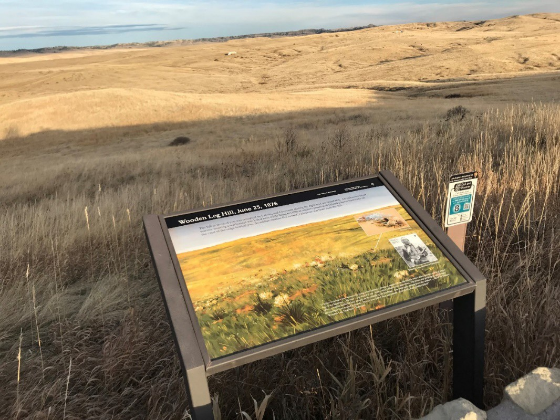
Little Bighorn Battlefield National Monument, Montana (photo by Phil Gruen, 2017)

CLASS SESSION TOPICS / TEAMSi |  | READINGS FOR THE WEEK / ASSIGNMENT DUE DATESii
Week One: Introduction
Jan. 8 | Introduction | Lewis, “Axioms for Reading the Landscape.” Jackson, “The Word Itself.”  Jackson, “Vernacular.”  Tuan, “Thought and Landscape.”
Jan. 10 Ordinary and Extraordinary
Landscapes
Week Two: Some Landscapes
Jan. 15 The Great Wall of Mart (and other tales of the American landscape)  Team arrangements |  | Jackson, “Other-Directed Houses.”  Banham, “The Transportation Palimpsest.” In Los Angeles: The Architecture of Four Ecologies.  Schwarzer, “Airplane.” In Zoomscape: Architecture in Motion and Media.
Jan. 17 | Landscapes in Motion CCE Visit
Week Three: Indigenous Landscapes
Jan. 22 | Trees, Boats, and Seahawks | Nabakov and Easton, “Introduction.” In Native American Architecture.  Swentzell, “Conflicting Landscape Values: The Santa Clara Pueblo and Day School.”  Washington State Office of Archaeology and Historic Preservation, “Washington’s First Builders.”
Jan. 24 Indigenous Landscapes / Team I Lead
Week Four: Rural Landscapes
Jan. 29 | Rolling Wheat | Dole, “The Calef’s Farm in Oregon: A Vermont Vernacular Comes West.” Noble, “The Diffusion of Silos.”  Washington State Office of Archaeology and Historic Preservation, “Bountiful Harvests.”
Jan. 31 | Rural Landscapes / Team II Lead
Week Five: Natural Landscapes
Feb. 5 | Cultivating the Wild | Cronon, “The Trouble with Wilderness; or, Getting Back to the Wrong Nature.” In  Uncommon Ground: Rethinking the Human Place in Nature.  Runte, “The American West.” In National Parks: The American Experience. Louter, “Glaciers and Gasoline: The Making of a Windshield Wilderness, 1900-  1915.”
Feb. 7 | Natural Landscapes / Team III Lead | Wikipedia Topic Due
Week Six: Urban Landscapes
Feb. 12 | Bulldozer | Jacobs, “Introduction.” In Death and Life of Great American Cities. Rybczyinski, “High Hopes.” In City Life.  Clay, “Stacks,” in Close-Up: How to Read the American City.

Feb. 14 | Urban Landscapes / Team IV Lead
Week Seven: Suburban Landscapes
Feb. 19 | The Mass-Produced House | Hayden, “Borderlands.” In Building Suburbia: Green Fields and Urban Growth, 1820-2000.  Bloomfield, “The Real Estate Associates: A Land and Housing Developer of the 1870s in San Francisco.”  Wright, “The Progressive Housewife and the Bungalow.” In Building the Dream: A Social History of Housing in America.
Feb. 21 | Early Suburban Landscapes / Team V Lead
Week Eight: Wartime Landscapes
Feb. 26 | The Landscape of War | Abbott, “War and the Westward Tilt, 1940-1950,” in The Metropolitan Frontier: Cities in the Modern American West.  Johnson, “The Making of Migrant Ghettos,” in The Second Gold Rush: Oakland and the East Bay in World War II.
Feb. 28 | Wartime Landscapes / Team VI Lead
Week Nine: Landscapes of Ethnicity, Race, and Religion
Mar. 5 | The Colonial Taco | Conzen, “Ethnicity on the Land.” In The Making of the American Landscape.  Upton, “Ethnicity, Authenticity, and Invented Traditions.”
Mar. 7 | Landscapes of Ethnicity, Race, and Religion / Team VII Lead | Wikipedia Entry Draft Due
Week S
Mar. 12 | Spring Break | No class
Mar. 14 | Spring Break | No class
Week Ten: Tourist Landscapes
Mar. 19 | Inventing Chinatown | Huxtable, “The Way It Never Was.” In The Unreal America: Architecture and Illusion.  Gruen, “Cosmpolitanism: Editing and Revising Culture.” In Manifest Destinations.
Mar. 21 | Tourist Landscapes / Team VIII Lead
Week Eleven: Local Landscapes
Mar. 26 | The Pull of Pullman | Stark, “A Local Folktale: The Founding of Pullman.”  Gumprecht, “Defining the College Town.” In The American College Town.  Jones, “Pullman is on the rise, so why is the Mimosa building left to rot in the middle of town?”
Mar. 28 | Local Landscapes / Team IX Lead

Week Twelve: Campus Grounds
Apr. 2 The Land Grant Campus | Gumprecht, “The Campus as Public Space,” in The American College Town.  Turner, “The Democratic College” in Campus: An American Planning Tradition.
Apr. 4 Campus Grounds / Team X Lead
Week Thirteen: WSU Landscapes
Apr. 9 Reflections and Presentation Preview  CCE Visit II | CCE Reflection Due
Apr. 11 WSU: Space (The Modern Frontier) | Turner, “Dynamism, Change, and Renewal.” In Campus: An American Planning Tradition.
Week Fourteen: Final Presentations I
Apr. 16 Final Presentations
Apr. 18 Final Presentations
Week Fifteen: Final Presentations II
Apr. 23 Final Presentations
Apr. 25 No class
Final Exam Week
May 2 Final Exam / 3:10pm-5:10pm | Wikipedia Entry Final Due on Friday, May 3, at 5:00pm

Reading Selections / Bibliography/
Abbott, Carl. “War and the Westward Tilt, 1940-1950.” In The Metropolitan Frontier: Cities in the Modern American West, 3-29. Tucson: University of Arizona Press, 1993.
Banham, Reyner. “The Transportation Palimpsest.” In Los Angeles: The Architecture of Four Ecologies,
75-93. New York: Harper and Row, 1971.
Clay, Grady. “Stacks.” In Close-Up: How to Read the American City, 127-42. Chicago: University of Chicago Press, 1973.
Conzen, Michael. “Ethnicity on the Land.” In Conzen, ed., The Making of the American Landscape,
221-48. Chicago: University of Chicago Press, 1990.
Cronon, William. “The Trouble with Wilderness; or, Getting Back to the Wrong Nature.”
Environmental History 1, no. 1 (Jan. 1996): 7-28.
Dole, Philip. “The Calef’s Farm in Oregon: A Vermont Vernacular Comes West.” In Thomas Carter, ed., Images of an American Land: Vernacular Architecture in the Western United States, 63-90. Albuquerque, NM: University of New Mexico Press, 1997.
Gruen, J. Philip. “Cosmpolitanism: Editing and Revising Culture.” In Manifest Destinations: Cities and Tourists in the Nineteenth-Century American West, 157-200. Norman: University of Oklahoma Press, 2014.

Gumprecht, Blake. Selections from The American College Town. Amherst: University of Massachusetts Press, 2009.

Hayden, Dolores. “Borderlands.” In Building Suburbia: Green Fields and Urban Growth, 1820-2000, 21-
44. New York: Pantheon Books, 2003.

Huxtable, Ada Louise. “The Way It Never Was.” In The Unreal America: Architecture and Illusion, 12-
37. New York: New Press, 1997.

Jackson, John Brinckerhoff. “The Word Itself.” In Discovering the Vernacular Landscape, 1-8. New Haven: Yale University Press, 1984.

Jackson, John Brinckerhoff. “Vernacular.” In Discovering the Vernacular Landscape, 83-87. New Haven: Yale University Press, 1984.

Jackson, John Brinckerhoff. “Other-Directed Houses.” In Helen Horowitz, ed., Landscape in Sight: Looking at America, 184-97. New Haven: Yale University Press, 1997.

Jacobs, Jane. “Introduction.” In Death and Life of Great American Cities, 3-25. New York: Random House, 1961.

Johnson, Marilynn S. “The Making of Migrant Ghettos.” In The Second Gold Rush: Oakland and the East Bay in World War II, 83-112. Berkeley: University of California Press, 1993.

Jones, Jacob. “Pullman is on the rise, so why is the Mimosa building left to rot in the middle of town?” Inlander (Spokane, WA), June 18, 2018.

Lewis, Pierce. “Axioms for Reading the Landscape.” In D.W. Meinig, ed., The Interpretation of Ordinary Landscapes, 11-32. Oxford: Oxford University Press, 1979.

Louter, David. “Glaciers and Gasoline: The Making of a Windshield Wilderness, 1900-1915.” In David M. Wrobel and Patrick T. Long, eds. Seeing and Being Seen: Tourism in the American West, 248-
70. Lawrence: University Press of Kansas, 2001.

Nabakov, Peter and Robert Easton. Native American Architecture. Oxford: Oxford University Press, 1999.

Noble, Allan. “The Diffusion of Silos.” Landscape 25, no. 1 (1981): 11-14.

Runte, Alfred. “The American West.” In National Parks: The American Experience, 4th ed., 10-27. Lanham, MD: Taylor Trade, 2010.

Schwarzer, Mitchell. “Airplane.” In Zoomscape: Architecture in Motion and Media, 119-63. New York: Princeton Architectural Press, 2004.
Stark, Lawrence B. “A Local Folktale: The Founding of Pullman.” Typescript. In author’s possession.
Swentzell, Rina. “Conflicting Landscape Values: The Santa Clara Pueblo and Day School.” In Groth and Bressi, eds., 56-66. Understanding Cultural Landscapes. New Haven: Yale University Press, 1997.
Tuan, Yi-Fu. “Thought and Landscape.” In Meinig, ed., The Interpretation of Ordinary Landscapes, 89-
102. Oxford: Oxford University Press, 1979.
Turner, Paul Venable. Selections from Campus: An American Planning Tradition, 249-305. New York: Architectural History Foundation/Cambridge, MA: The MIT Press, 1984.
Upton, Dell. “Ethnicity, Authenticity, and Invented Traditions.” Historical Archaeology 30, no. 2 (1996): 1-7.
Washington State Office of Archaeology and Historic Preservation. “Washington’s First Builders.” In Built in Washington: 12,000 Years of Pacific Northwest Archaeological Sites and Historic Buildings, 11-
23. Pullman: Washington State University Press, 1989.
Washington State Office of Archaeology and Historic Preservation. “Bountiful Harvests.” In Built in Washington: 12,000 Years of Pacific Northwest Archaeological Sites and Historic Buildings, 42-55.
Pullman, WA: WSU Press, 1989.
Wright, Gwendolyn. “The Progressive Housewife and the Bungalow.” 158-76. Building the Dream: A Social History of Housing in America. New York: Pantheon Books, 1981.

i Updates or changes to the syllabus (such as due dates, assignment parameters, class topics, or readings) will be announced in class and/or posted to Blackboard. Early exams will not be given per WSU Academic Regulations 79 and 80.

ii Readings should be completed prior to the week’s class sessions.

